**Cloud Computing: UE20CS352**

**Assignment 2b KUBERNETES**

**-Adithya M, Section K**

**-PES1UG20CS621**

**1. Section 1: Installation**

Screenshot 1a - Minikube running successfully

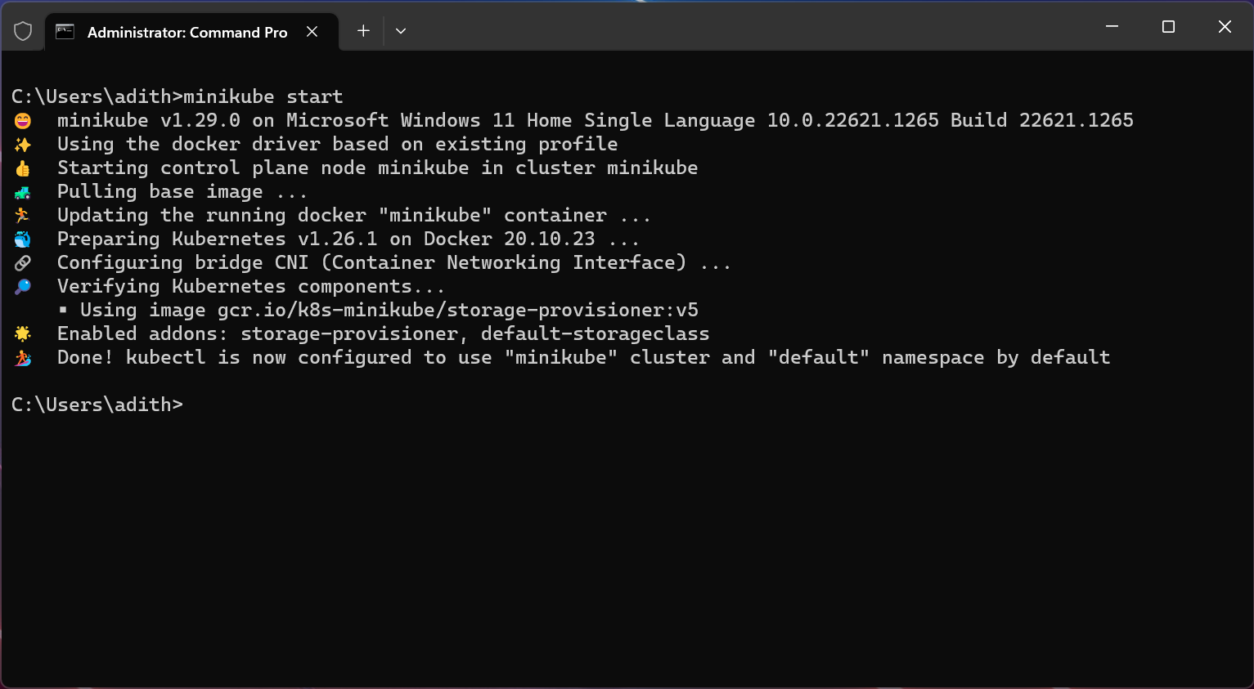

**2. Section 2: Creating pods and deployments, Editing them and observing Rollback:-**

●Screenshot 2a - get nodes, pod and services command.

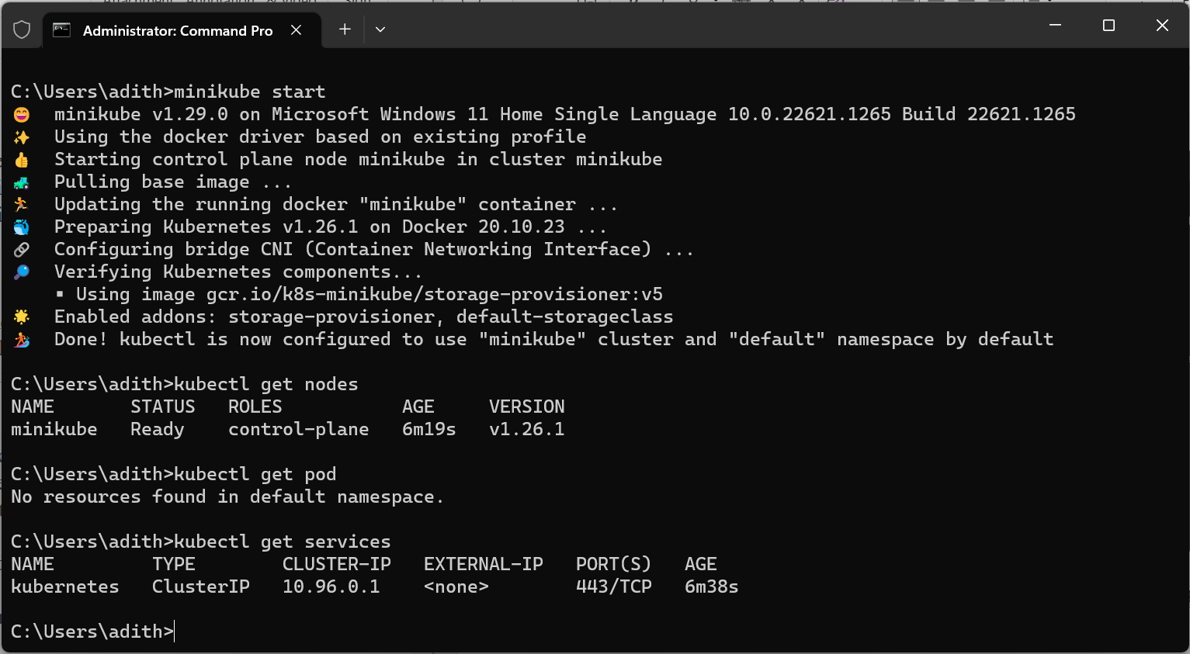

● Screenshot 2b- Deployment created.

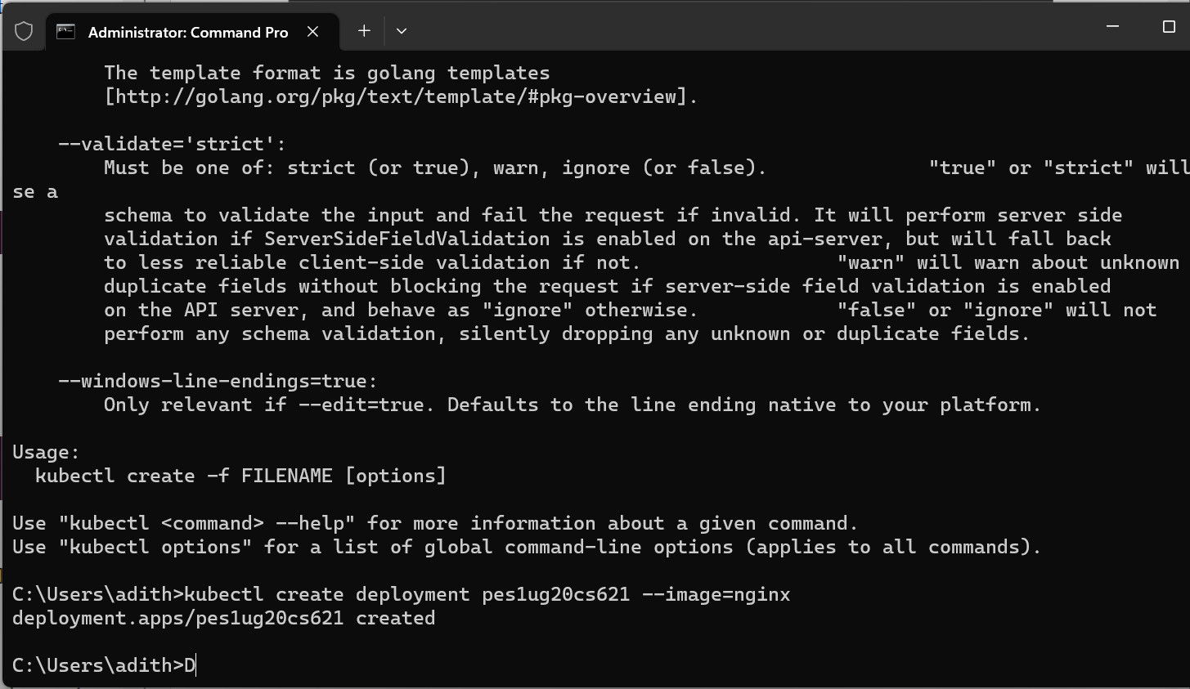

● Screenshot 2c- get deployment and pod command .

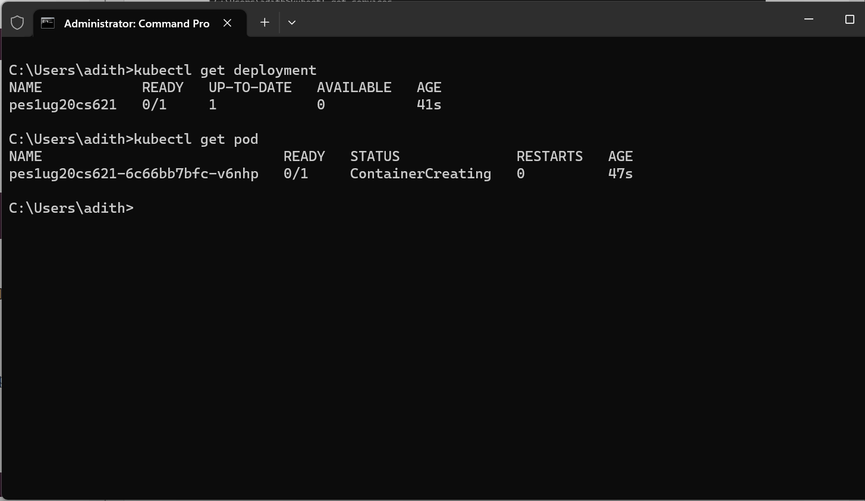

● Screenshot 2d- editing ‘-image:nginx.’

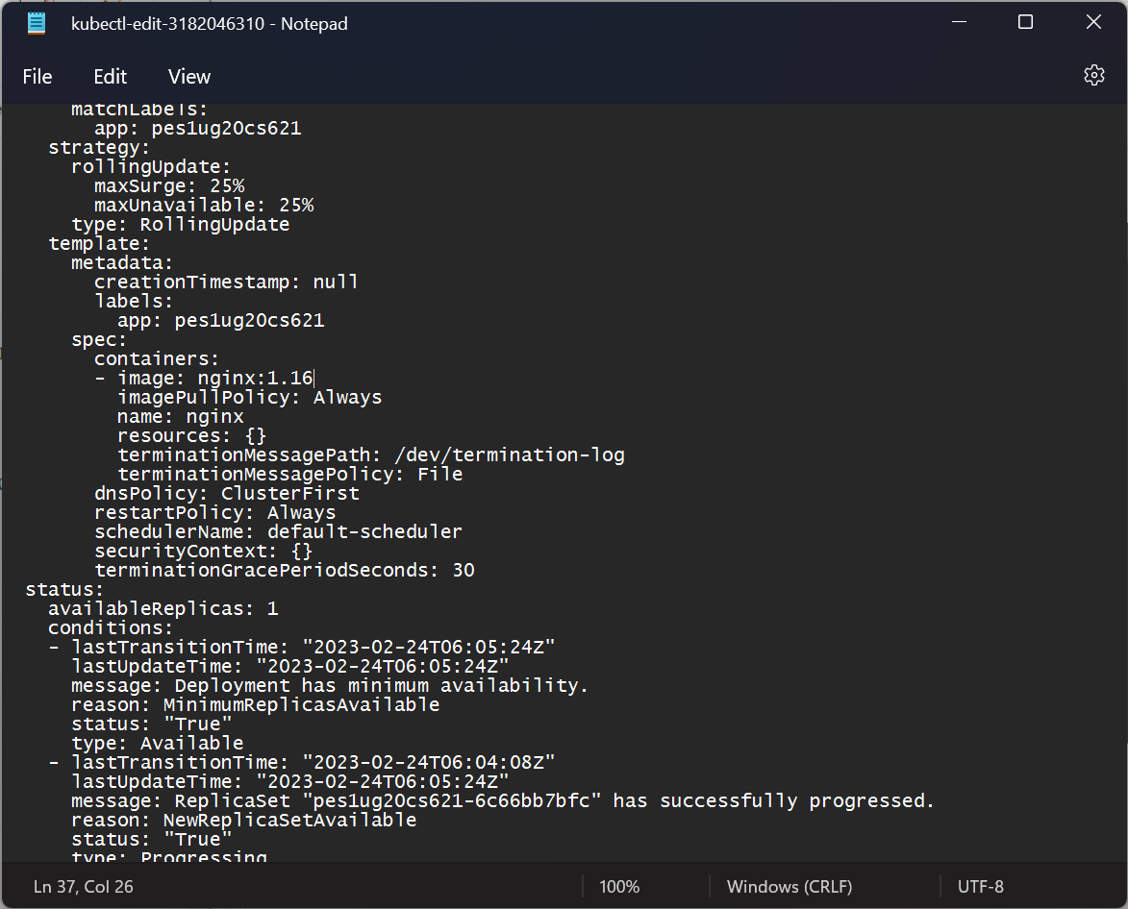

● Screenshot 2e- showing edited deployment.

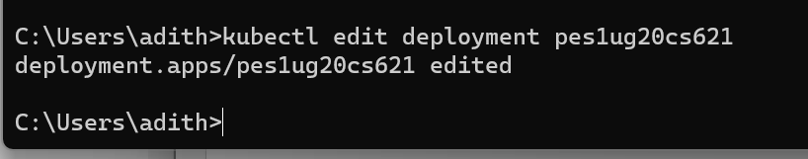

● Screenshot 2f- deployment is rolled back.

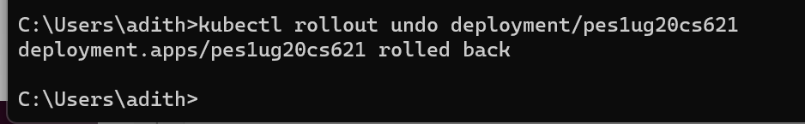

● Screenshot 2g- showing original nginx image.

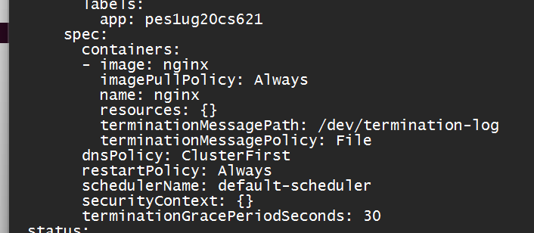

**3. Section 3:Debugging Pods:-**

● Screenshot 3a - Kubectl logs displayed.

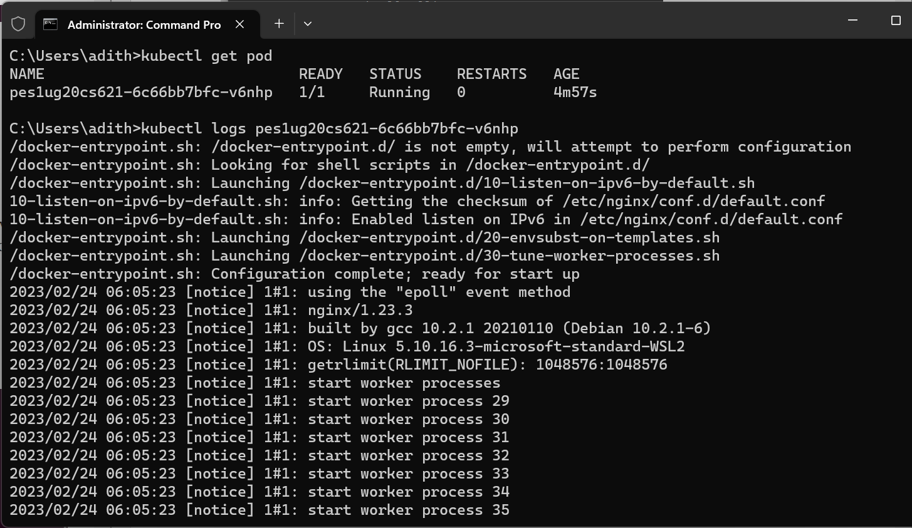

● Screenshot 3b- Kubectl ‘describe pod ‘ command.

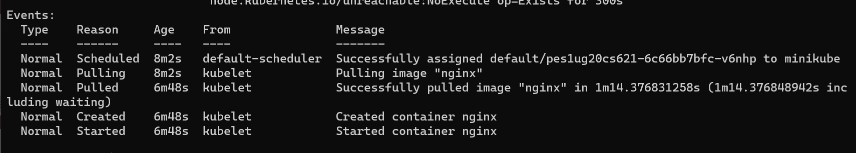

● Screenshot 3c - Create mongo deployment.

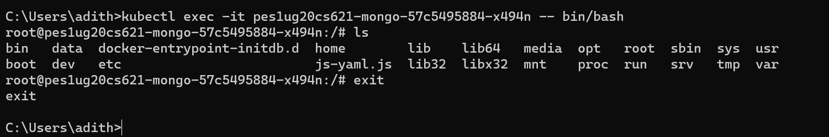

● Screenshot 3d - Delete both requirements.

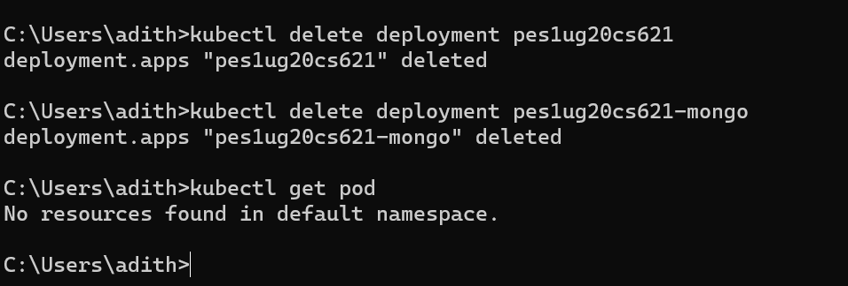

**4. Section 4: Applying configuration files:-**

● Screenshot 4a - Kubectl apply command on yaml file.



● Screenshot 4b- Kubectl get on yaml file

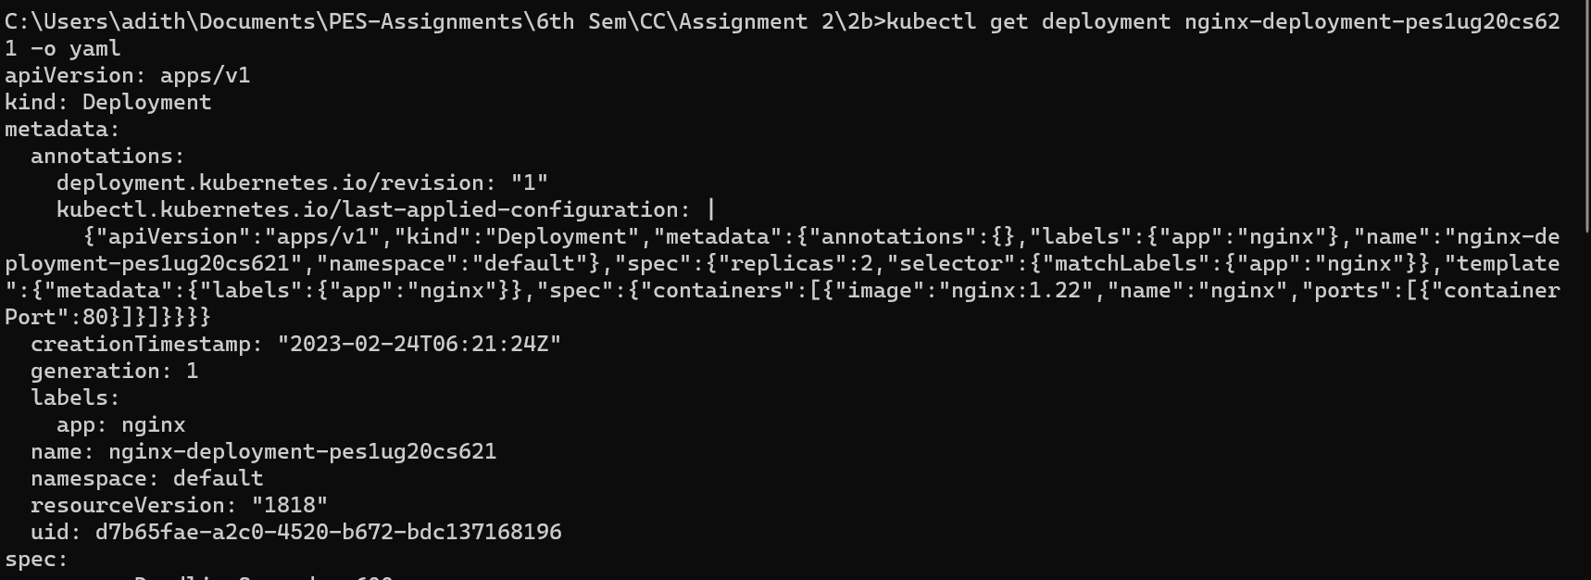

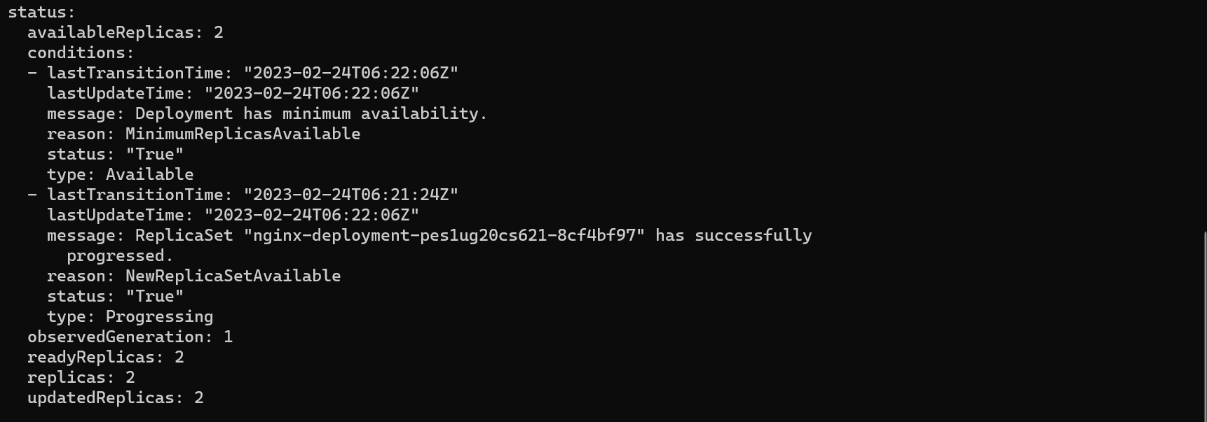

**5. Section 5: Delete a pod to observe the self-healing feature.**

● Screenshot 5a - Deleted pod:-

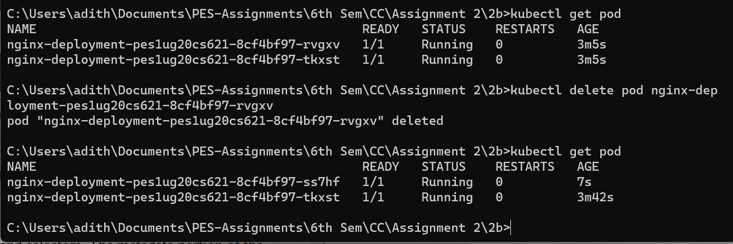

**6. Section 6 : Connecting Services to Deployments**

● Screenshot 6a- Kubectl apply and get command.

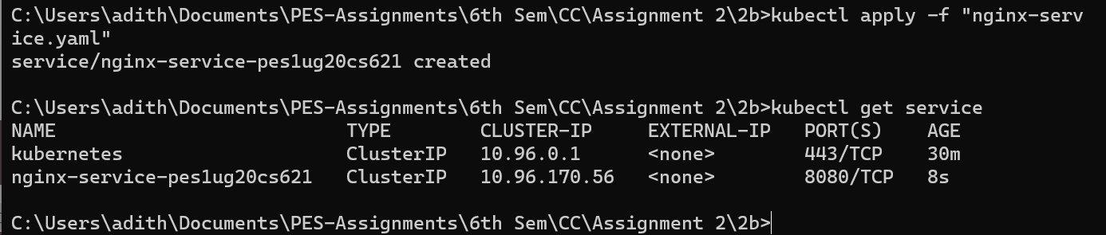

● Screenshot 6b-kubectl get pod -o wide command



**7. Section 7: Port Forwarding:-**

● Screenshot 7a -Kubectl port-forward command



● Screenshot 7b- Display welcome to nginx on web page

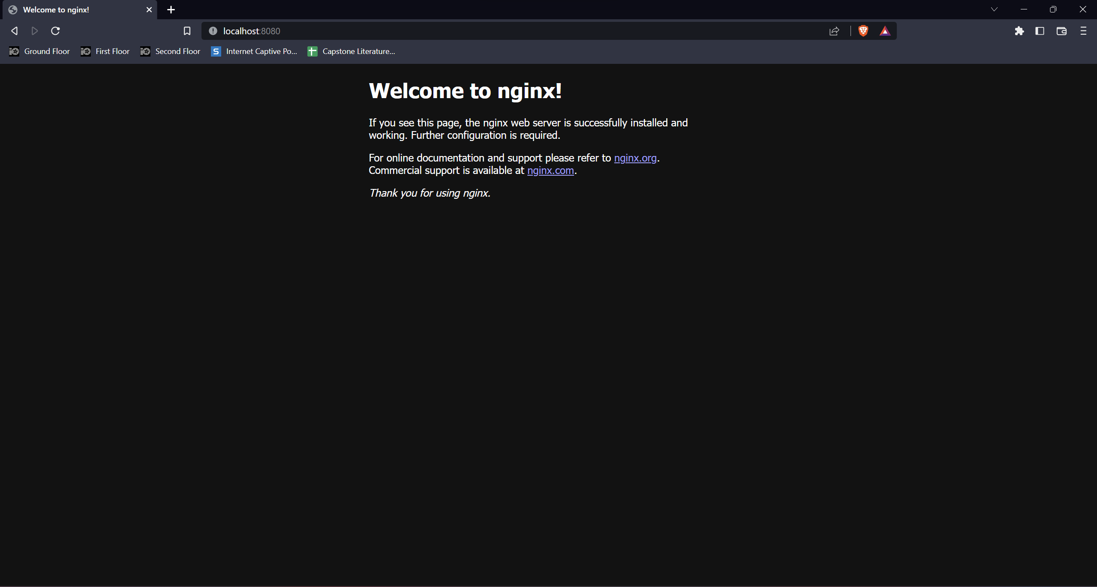

**8. Section 8: Deleting service/deployment and Cleanup**

● Screenshot 8a - Delete nginx deployments

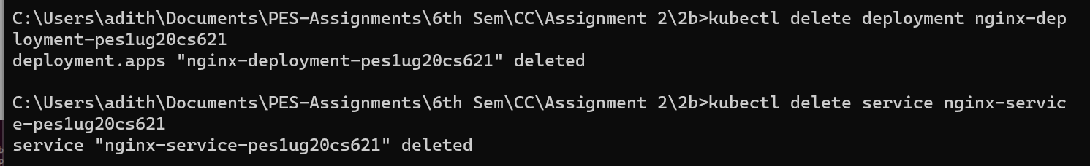

● Screenshot 8b - stop minikube

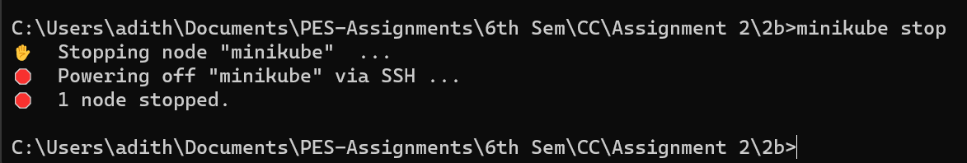

**9. Section 9: Expose an external IP address to access an Application in a cluster**

● Screenshot 9a- the command which exposes specifies the type of service (NodePort)





● Screenshot 9b - kubectl get service command which displays the node port

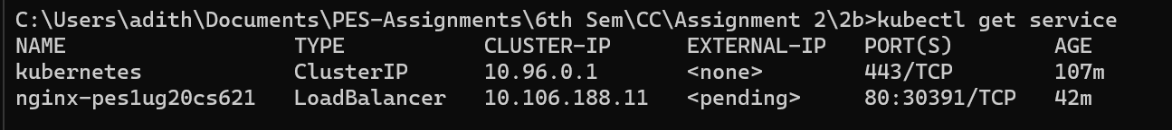

● Screenshot 9c - minikube IP address

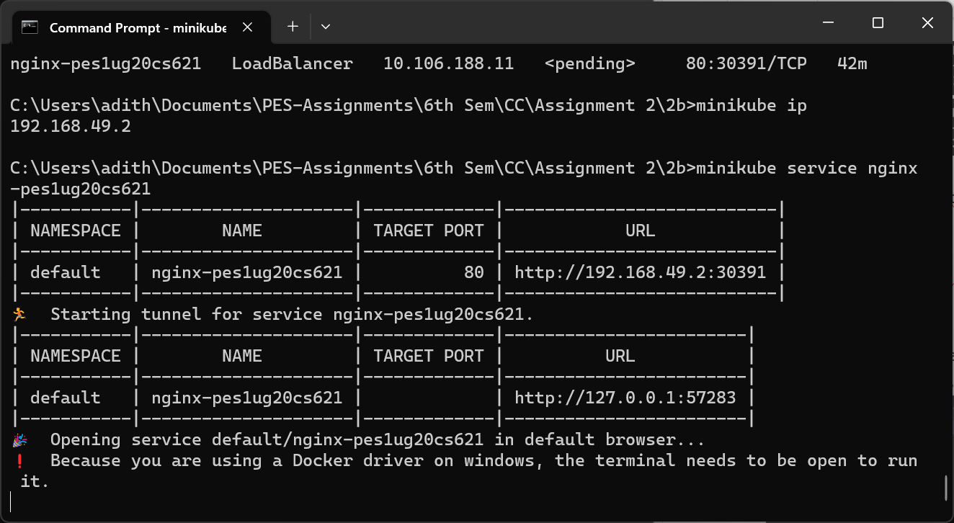

● Screenshot 9d - the webpage with the IP Address visible. (If the IP Address is not

visible in the screenshot, you will lose significant portion of marks w.r.t. Section 9)

